**MA4605 Lecture 10B Experimental Design ( One Way ANOVA)**

Last class:

* Introduction to Experimental Design
* Factors and levels of a factor
* Controllable factors
* Treatments and Blocks
* Randomization and Randomized block design from experiments.

This class:

* One Way ANOVA
* Graphical Analysis
* Linear Statistical Model
* R implementation

**Example: Tensile Strength**

A manufacturer of paper used for making grocery bags is interested in improving the tensile strength of the product. Product engineering thinks that tensile strength is a function of the hard-wood concentration in the pulp and that the range of hardwood concentrations of practical interest is between 5 and 20%. A team of engineers responsible for the study decides to investigate four levels of hardwood concentration: 5%, 10%, 15%, and 20%.

They decide to make up six test specimens at each concentration level, using a pilot plant. All 24 specimens are tested on a laboratory tensile tester, in random order. The data from this experiment are shown in the table below.



(The average for each of the treatment groups are 10.00, 15.67, 17.00, 21.17.)

Remark: This is an example of a ***completely randomized*** *(single-factor)* ***experiment*** with four levels of the factor.

Recall - the levels of the factor are sometimes called treatments. and each treatment has six observations or replicates.

***Importance of randomization***

The role of randomization in this experiment is extremely important.

By randomizing the order of the 24 runs, the effect of any nuisance variable that may influence the observed tensile strength is approximately balanced out.

For example, suppose that there is a warm-up effect on the tensile testing machine; that is, the longer the machine is on, the greater the observed tensile strength.

lf all 24 runs are made in order of increasing hardwood concentration (that is, all six 5% concentration specimens are tested first, followed by all six 10% concentration specimens, etc.), any observed differences in tensile strength could also be due to the warm-up effect.

***Graphical Analysis***

lt is important to graphically analyze the data from a designed experiment. Box plots of tensile strength at the four hardwood concentration levels are presented below.

The overall median (17) is marked as a horizontal red line. The overall mean (15.9) is marked as a horizontal blue line. Recall that the boxplot is used to express the location of the median and the width of the inter-quartile range.

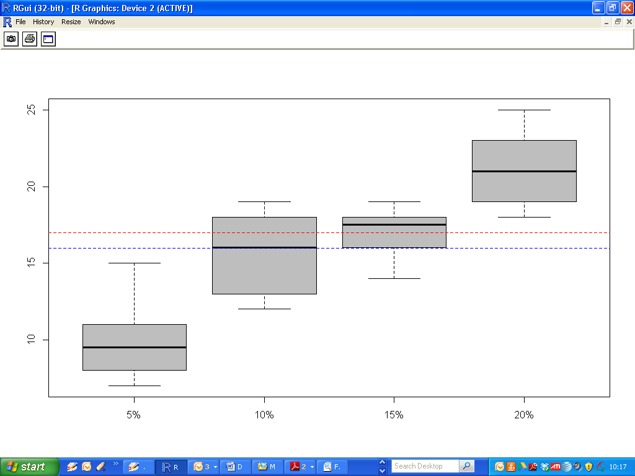

Graphical interpretation of the data is always useful. Box plots show the variability of the observations ***within*** a treatment (factor level) and the variability ***between*** treatments.

This figure indicates that changing the hardwood concentration has an effect on tensile strength; specifically, higher hardwood concentrations produce higher observed tensile strength.

Furthermore, the distribution of tensile strength at a particular hardwood level is reasonably symmetric, and the variability in tensile strength does not change dramatically as the hardwood concentration changes. (i.e. the boxplots are more less the same length. The treatment has no effect on variability of observations)

***Important*** - when given a set of boxplots, comment upon the location and dimension of each.

We now discuss how the data from a single-factor randomized experiment can be analyzed statistically.

**Linear Statistical Model (One-Way ANOVA)**

An observation ( such as in the previous table of results) is denoted ***yij.*** This represents the ***j-***th observation taken under treatment ***i***.

We consider the case in which there are an equal number of observations, ***n***, on each treatment.

So we may describe the observations by the following linear statistical model





|  |  |
| --- | --- |
|  | This is a parameter common to all treatments called the ***overall mean,*** or ***grand mean.*** |
|  | is a parameter associated with the ***i***th treatment called the ***i***th ***treatment effect*** |
| ***eij*** | is a random error component. |

For the first group (5%) , with mean = 10:

and  would be 15.90 and -5.90 respectively. The difference between each observation and the group mean 10 is captured in the random error component.

|  |
| --- |
| The first two terms is sometimes combined to a single term, i.e. the mean for each group. |

This first equation is the underlying model for a single-factor experiment.

Furthermore, since we require that the observations are taken in random order and that the environment (the experimental units) in which the treatments are used is as uniform as possible, this experimental design is a completely randomized design (CRD).

**Testing for Differences:**

We are interested in testing the equality of the treatment means. We find that this is equivalent to testing the hypotheses.



Thus, if the null hypothesis is true, each observation consists of the overall mean ***μ*** plus a realization of the random error component ***eij.***

This is equivalent to saying that all observations are taken from a normal distribution with mean ***μ***. and variance ***σ2***.

Therefore, if the null hypothesis is true, changing the levels of the factor has no effect on the mean response.

The null hypothesis states that there are differences between treatment means.

**Using the ANOVA procedure**

The ANOVA partitions the total variability in the sample data into two component parts.

*In this table the number of groups is denoted “a” ( although “k” is commonly used also). There are “n” observations (i.e 6) in each of the groups. The total number of observations is “an” (i.e. 24)*



The total variability in the data is described by the total sum of squares**.** The ANOVA partitions the total variability in the sample data into two component parts: Sum of Squares between groups (SSB) and Sum of Squares Within Groups (SSW). This terminology may alter to suit the experiment – we will work in the context of treatments and residual errors.



This identity shows that the total variability in the data, measured by the total corrected sum of squares ***SST***, can be partitioned into a sum of squares of differences between treatment means and the grand mean (i.e. ***SSTreatments***) and a sum of squares of differences of observations within a treatment from the treatment mean (here denoted ***SSE***).

* Differences between observed treatment means and the grand mean measure the ***differences between treatments***
* Differences of observations within a treatment from the treatment mean can be due only to random error.

The test statistic for this test is computed using the following terms. A p-value will be provided in the associated ***R*** code.



|  |
| --- |
| > summary(Model)  Df Sum Sq Mean Sq F value Pr(>F)  Treatment 3 382.8 127.60 19.61 3.59e-06 ***  Residuals 20 130.2 6.51  ---  Signif. codes: 0 ‘***’ 0.001 ‘**’ 0.01 ‘*’ 0.05 ‘.’ 0.1 ‘ ’ 1 |

Not present in the ***R*** code out is the total Sum of Squares (513) and the overall degrees of freedom : 24 – 1 = 23.

For this data set, we reject the null hypothesis and conclude that there is a treatment effect. There is strong evidence to conclude that hardwood concentration has an effect on tensile strength. However, the ANOVA does not tell as which levels of hardwood concentration result in different tensile strength means.